**Console Output with plots**

**Anjali Jha**

**Email: anjalijha167@gmail.com**

**Contact: 9672076045**

**> air.df<-read.csv(paste("SixAirlines.csv",sep=""))**

**> library(psych)**

**> summary(air.df)**

**AIRLINE AIRCRAFT FLIGHT_DURATION MONTH**

**AirFrance: 74 Min. :0.0000 Min. : 1.250 Min. :0.000**

**British :175 1st Qu.:0.0000 1st Qu.: 4.250 1st Qu.:1.000**

**Delta : 46 Median :0.0000 Median : 7.750 Median :2.000**

**Jet : 65 Mean :0.3268 Mean : 7.549 Mean :1.671**

**Singapore: 40 3rd Qu.:1.0000 3rd Qu.:10.500 3rd Qu.:3.000**

**Virgin : 62 Max. :1.0000 Max. :14.660 Max. :3.000**

**INTERNATIONAL SEATS_ECONOMY SEATS_PREMIUM PITCH_ECONOMY**

**Min. :0.0000 Min. : 17.0 Min. : 8.00 Min. :30.00**

**1st Qu.:1.0000 1st Qu.:127.0 1st Qu.:21.00 1st Qu.:31.00**

**Median :1.0000 Median :185.0 Median :36.00 Median :31.00**

**Mean :0.9134 Mean :200.7 Mean :33.54 Mean :31.21**

**3rd Qu.:1.0000 3rd Qu.:243.0 3rd Qu.:40.00 3rd Qu.:32.00**

**Max. :1.0000 Max. :389.0 Max. :66.00 Max. :33.00**

**PITCH_PREMIUM WIDTH_ECONOMY WIDTH_PREMIUM PRICE_ECONOMY**

**Min. :34.00 Min. :17.00 Min. :17.00 Min. : 65.0**

**1st Qu.:38.00 1st Qu.:17.00 1st Qu.:19.00 1st Qu.: 404.8**

**Median :38.00 Median :18.00 Median :19.00 Median :1224.0**

**Mean :37.92 Mean :17.83 Mean :19.48 Mean :1317.1**

**3rd Qu.:38.00 3rd Qu.:18.00 3rd Qu.:21.00 3rd Qu.:1903.0**

**Max. :40.00 Max. :19.00 Max. :21.00 Max. :3593.0**

**PRICE_PREMIUM PRICE_RELATIVE N LAMBDA**

**Min. : 86 Min. :0.0200 Min. : 38.0 Min. :0.0500**

**1st Qu.: 524 1st Qu.:0.1000 1st Qu.:162.0 1st Qu.:0.1200**

**Median :1710 Median :0.3800 Median :227.0 Median :0.1300**

**Mean :1832 Mean :0.4926 Mean :234.2 Mean :0.1503**

**3rd Qu.:2989 3rd Qu.:0.7475 3rd Qu.:279.0 3rd Qu.:0.1500**

**Max. :7414 Max. :1.8900 Max. :441.0 Max. :0.5500**

**QUALITY**

**Min. : 2.000**

**1st Qu.: 6.000**

**Median : 7.000**

**Mean : 6.716**

**3rd Qu.: 7.000**

**Max. :10.000**

**>boxplot(air.df$PRICE_ECONOMY,horizontal=TRUE,xlab="Price of economy seats",main="Average Price of economy seats")**

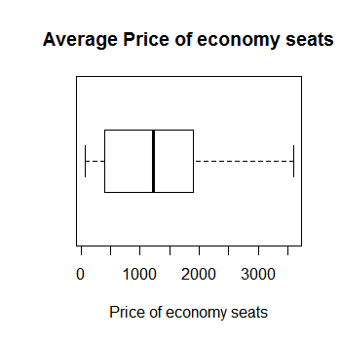

**>boxplot(air.df$PRICE_PREMIUM,horizontal=TRUE,xlab="Price of premium seats",main="Average Price of permium seats")**

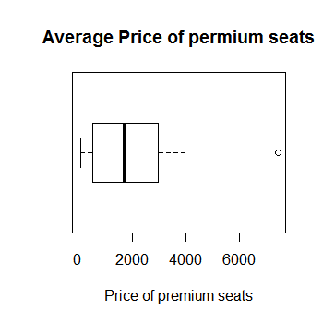

**>boxplot(air.df$N,horizontal=TRUE,main="Average No.of seats")**

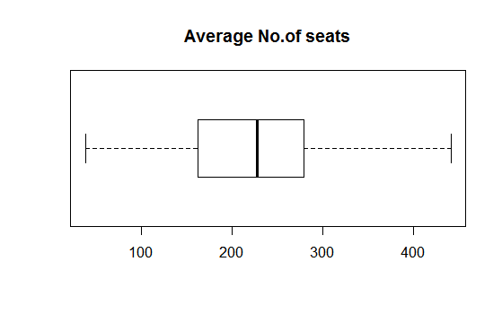

**>boxplot(PRICE_ECONOMY~AIRLINE,data=air.df,horizontal=TRUE,xlab="Price of economy seats",ytab="Airline",main="price of economy seats in each airline",las=1)**

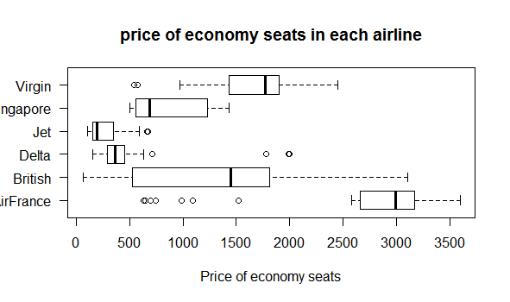

**>boxplot(PRICE_PREMIUM~AIRLINE,data=air.df,horizontal=TRUE,xlab="Price of PREMIUM seats",ytab="Airline",main="price of Premium seats in each airline",las=1)**

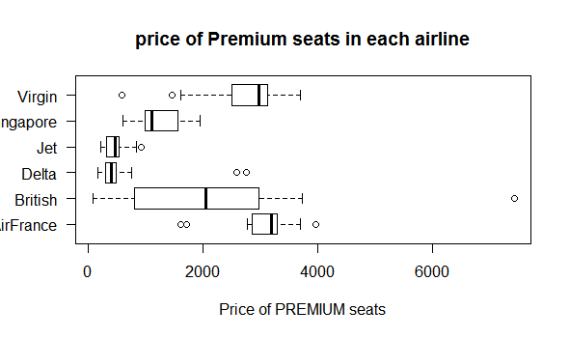

**>boxplot(N~AIRLINE,data=air.df,horizontal=TRUE,xlab="No.of seats",ytab="Airline",main="No.of seats in each airline seats in each airline",las=1)**

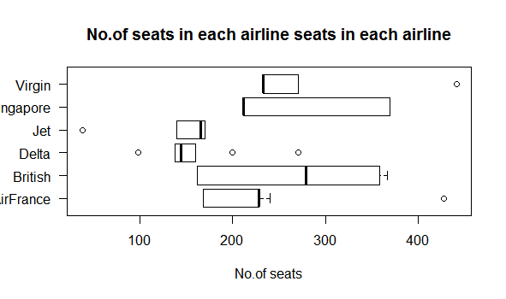

**>boxplot(N~AIRLINE,data=air.df,horizontal=TRUE,xlab="No.of seats",ytab="Airline",main="N0.of economy seats in each airline seats in each airline",las=1)**

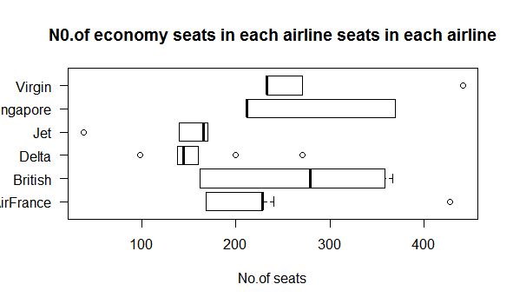

**>boxplot(N~AIRLINE,data=air.df,horizontal=TRUE,xlab="No.of seats",ytab="Airline",main="No.of permium seats in each airline seats in each airline",las=1)**

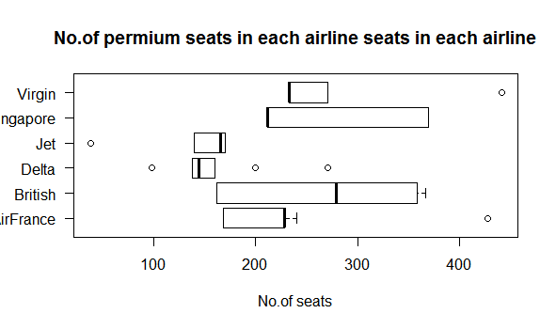

**>library(car)**

**Attaching package: ‘car’**

**The following object is masked from ‘package:psych’:**

**logit**

**>scatterplotMatrix(formula=~PRICE_ECONOMY+SEATS_ECONOMY,cex=0.6,data=air.df,diagonal="histogram")**

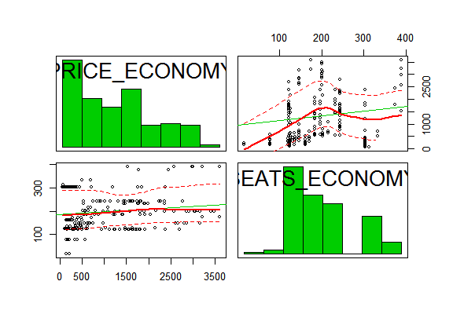

**>scatterplotMatrix(formula=~PRICE_PREMIUM+SEATS_PREMIUM,cex=0.6,data=air.df,diagonal="histogram")**

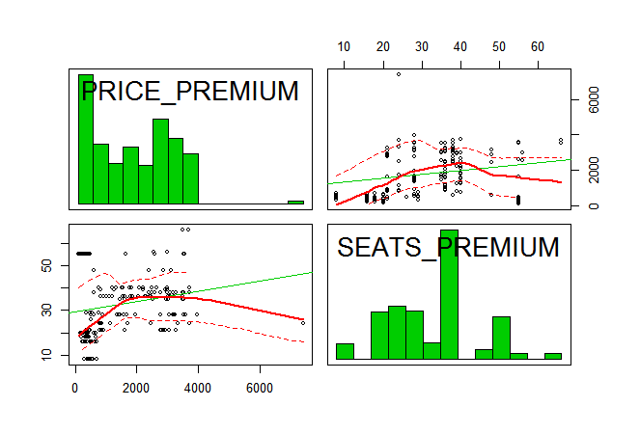

**>scatterplotMatrix(formula=~N+SEATS_PREMIUM+SEATS_ECONOMY,cex=0.6,data=air.df,diagonal="histogram")**

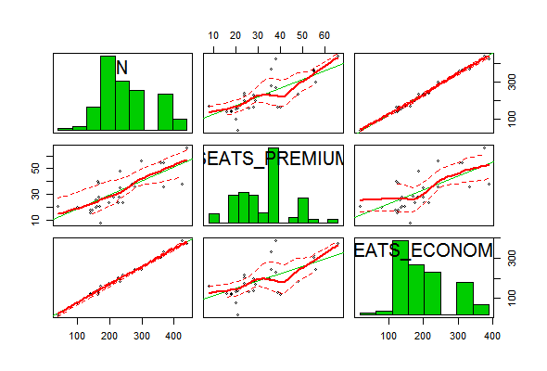

**>library(corrgram)**

**Warning message:**

**package ‘corrgram’ was built under R version 3.4.1**

**>corrgram(air.df, main = "corrgram of Sixairplane variables", lower.panel = panel.shade, upper.panel = panel.pie, text.panel = panel.txt,order=TRUE)**

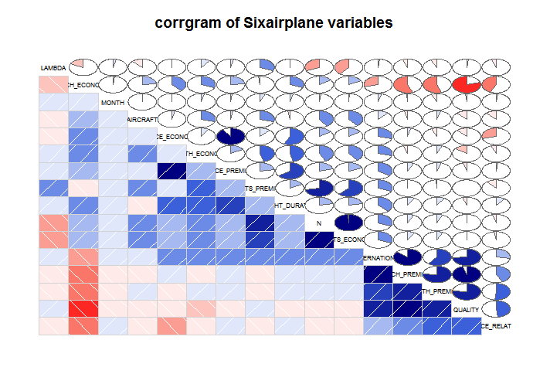

**>air1.df<-air.df[-c(1)]**

**>cov(air1.df)**

**AIRCRAFT FLIGHT_DURATION MONTH INTERNATIONAL**

**AIRCRAFT 0.220492812 -3.701285e-02 0.003643500 1.534402e-02**

**FLIGHT_DURATION -0.037012846 1.253262e+01 0.159093163 3.690261e-01**

**MONTH 0.003643500 1.590932e-01 1.106271892 1.266774e-02**

**INTERNATIONAL 0.015344020 3.690261e-01 0.012667737 7.925552e-02**

**SEATS_ECONOMY 14.696579993 5.776481e+01 1.120573570 6.755557e+00**

**SEATS_PREMIUM 1.838648336 7.870071e+00 0.756880863 1.153055e+00**

**PITCH_ECONOMY 0.075104938 7.107017e-01 0.014282897 -5.355382e-02**

**PITCH_PREMIUM -0.025077237 3.839608e-01 -0.011963452 3.209755e-01**

**WIDTH_ECONOMY 0.076992422 9.176009e-01 0.020255233 4.608840e-02**

**WIDTH_PREMIUM 0.019062644 3.547466e-01 -0.076579241 1.895747e-01**

**PRICE_ECONOMY 17.323632983 1.999429e+03 3.101670564 8.333535e+01**

**PRICE_PREMIUM 12.170728043 2.976982e+03 25.684686969 1.255051e+02**

**PRICE_RELATIVE -0.025507038 1.735896e-01 0.009525782 3.539182e-02**

**N 16.535228329 6.563488e+01 1.877454433 7.908612e+00**

**LAMBDA -0.003692613 7.567372e-04 0.002478613 3.120451e-04**

**QUALITY -0.100182175 -3.267410e-01 -0.026246349 3.745293e-01**

**SEATS_ECONOMY SEATS_PREMIUM PITCH_ECONOMY PITCH_PREMIUM**

**AIRCRAFT 14.6965800 1.83864834 0.075104938 -0.025077237**

**FLIGHT_DURATION 57.7648124 7.87007057 0.710701749 0.383960757**

**MONTH 1.1205736 0.75688086 0.014282897 -0.011963452**

**INTERNATIONAL 6.7555568 1.15305519 -0.053553821 0.320975481**

**SEATS_ECONOMY 6077.6910021 647.73917514 9.091218976 8.522283573**

**SEATS_PREMIUM 647.7391751 175.71539848 -0.162126377 -0.143462828**

**PITCH_ECONOMY 9.0912190 -0.16212638 0.438290560 -0.491816210**

**PITCH_PREMIUM 8.5222836 -0.14346283 -0.491816210 1.749129034**

**WIDTH_ECONOMY 17.1089106 3.43175480 0.115418204 -0.032340761**

**WIDTH_PREMIUM 6.0725695 -0.20548215 -0.400315520 1.099717347**

**PRICE_ECONOMY 11433.0342001 1602.26644505 248.750035214 44.030960363**

**PRICE_PREMIUM 19639.2185537 3847.35524129 204.823759754 121.694406100**

**PRICE_RELATIVE -0.8657126 -0.64405105 -0.130376370 0.256361007**

**N 6725.4301772 823.45457363 8.929092599 8.378820745**

**LAMBDA -1.9029572 0.25651576 -0.006991858 -0.004355485**

**QUALITY -0.5689354 0.01866355 -0.930106770 2.240945244**

**WIDTH_ECONOMY WIDTH_PREMIUM PRICE_ECONOMY PRICE_PREMIUM**

**AIRCRAFT 0.076992422 0.019062644 1.732363e+01 1.217073e+01**

**FLIGHT_DURATION 0.917600924 0.354746598 1.999429e+03 2.976982e+03**

**MONTH 0.020255233 -0.076579241 3.101671e+00 2.568469e+01**

**INTERNATIONAL 0.046088402 0.189574706 8.333535e+01 1.255051e+02**

**SEATS_ECONOMY 17.108910612 6.072569513 1.143303e+04 1.963922e+04**

**SEATS_PREMIUM 3.431754796 -0.205482153 1.602266e+03 3.847355e+03**

**PITCH_ECONOMY 0.115418204 -0.400315520 2.487500e+02 2.048238e+02**

**PITCH_PREMIUM -0.032340761 1.099717347 4.403096e+01 1.216944e+02**

**WIDTH_ECONOMY 0.314167394 0.038651154 4.547520e+01 1.179328e+02**

**WIDTH_PREMIUM 0.038651154 1.213435877 -7.651962e+01 7.008986e+01**

**PRICE_ECONOMY 45.475195087 -76.519621376 9.797165e+05 1.152371e+06**

**PRICE_PREMIUM 117.932783052 70.089857359 1.152371e+06 1.664025e+06**

**PRICE_RELATIVE -0.015475111 0.255376323 -1.336887e+02 1.027099e+01**

**N 20.540665408 5.867087359 1.303530e+04 2.348657e+04**

**LAMBDA 0.003334085 -0.004853744 -3.434499e-01 2.801268e+00**

**QUALITY -0.147758966 1.500032867 -2.047191e+02 -8.312935e+01**

**PRICE_RELATIVE N LAMBDA QUALITY**

**AIRCRAFT -2.550704e-02 16.5352283 -0.0036926125 -1.001822e-01**

**FLIGHT_DURATION 1.735896e-01 65.6348829 0.0007567372 -3.267410e-01**

**MONTH 9.525782e-03 1.8774544 0.0024786132 -2.624635e-02**

**INTERNATIONAL 3.539182e-02 7.9086120 0.0003120451 3.745293e-01**

**SEATS_ECONOMY -8.657126e-01 6725.4301772 -1.9029571513 -5.689354e-01**

**SEATS_PREMIUM -6.440510e-01 823.4545736 0.2565157619 1.866355e-02**

**PITCH_ECONOMY -1.303764e-01 8.9290926 -0.0069918585 -9.301068e-01**

**PITCH_PREMIUM 2.563610e-01 8.3788207 -0.0043554854 2.240945e+00**

**WIDTH_ECONOMY -1.547511e-02 20.5406654 0.0033340846 -1.477590e-01**

**WIDTH_PREMIUM 2.553763e-01 5.8670874 -0.0048537435 1.500033e+00**

**PRICE_ECONOMY -1.336887e+02 13035.3006451 -0.3434498690 -2.047191e+02**

**PRICE_PREMIUM 1.027099e+01 23486.5737950 2.8012680884 -8.312935e+01**

**PRICE_RELATIVE 2.052828e-01 -1.5097636 -0.0013872506 3.867374e-01**

**N -1.509764e+00 7548.8847508 -1.6464413894 -5.502719e-01**

**LAMBDA -1.387251e-03 -1.6464414 0.0037413115 2.636373e-03**

**QUALITY 3.867374e-01 -0.5502719 0.0026363730 3.171052e+00**

**>t.test(N~AIRCRAFT,data=air.df)**

**Welch Two Sample t-test**

**data: N by AIRCRAFT**

**t = -8.9886, df = 258.16, p-value < 2.2e-16**

**alternative hypothesis: true difference in means is not equal to 0**

**95 percent confidence interval:**

**-91.42114 -58.56314**

**sample estimates:**

**mean in group 0 mean in group 1**

**209.7363 284.7285**

**>t.test(SEATS_ECONOMY~AIRCRAFT,data=air.df)**

**Welch Two Sample t-test**

**data: SEATS_ECONOMY by AIRCRAFT**

**t = -8.9447, df = 262.2, p-value < 2.2e-16**

**alternative hypothesis: true difference in means is not equal to 0**

**95 percent confidence interval:**

**-81.32609 -51.98057**

**sample estimates:**

**mean in group 0 mean in group 1**

**178.9228 245.5762**

**>t.test(SEATS_PREMIUM~AIRCRAFT,data=air.df)**

**Welch Two Sample t-test**

**data: SEATS_PREMIUM by AIRCRAFT**

**t = -6.4301, df = 274.73, p-value = 5.627e-10**

**alternative hypothesis: true difference in means is not equal to 0**

**95 percent confidence interval:**

**-10.891813 -5.785813**

**sample estimates:**

**mean in group 0 mean in group 1**

**30.81350 39.15232**

**>t.test(PRICE_PREMIUM~AIRCRAFT,data=air.df)**

**Welch Two Sample t-test**

**data: PRICE_PREMIUM by AIRCRAFT**

**t = -0.43785, df = 309.53, p-value = 0.6618**

**alternative hypothesis: true difference in means is not equal to 0**

**95 percent confidence interval:**

**-303.2518 192.8561**

**sample estimates:**

**mean in group 0 mean in group 1**

**1814.305 1869.503**

**t.test(PRICE_ECONOMY~AIRCRAFT,data=air.df)**

**Welch Two Sample t-test**

**data: PRICE_ECONOMY by AIRCRAFT**

**t = -0.79106, df = 288.69, p-value = 0.4296**

**alternative hypothesis: true difference in means is not equal to 0**

**95 percent confidence interval:**

**-274.0507 116.9151**

**sample estimates:**

**mean in group 0 mean in group 1**

**1291.386 1369.954**

**>reg1<-lm(PRICE_ECONOMY~FLIGHT_DURATION+SEATS_ECONOMY+PITCH_ECONOMY+WIDTH_ECONOMY+QUALITY+MONTH+AIRCRAFT+AIRLINE,data=air.df)**

**>summary(reg1)**

**Call:**

**lm(formula = PRICE_ECONOMY ~ FLIGHT_DURATION + SEATS_ECONOMY +**

**PITCH_ECONOMY + WIDTH_ECONOMY + QUALITY + MONTH + AIRCRAFT +**

**AIRLINE, data = air.df)**

**Residuals:**

**Min 1Q Median 3Q Max**

**-2130.19 -258.90 92.13 334.17 1194.38**

**Coefficients:**

**Estimate Std. Error t value Pr(>|t|)**

**(Intercept) -1.079e+04 5.034e+03 -2.143 0.032632 \***

**FLIGHT_DURATION 1.055e+02 9.317e+00 11.320 < 2e-16 \*\*\***

**SEATS_ECONOMY -7.401e-01 3.912e-01 -1.892 0.059128 .**

**PITCH_ECONOMY 3.324e+02 1.391e+02 2.390 0.017261 \***

**WIDTH_ECONOMY 3.904e+01 1.001e+02 0.390 0.696744**

**QUALITY 2.640e+02 6.126e+01 4.310 2.00e-05 \*\*\***

**MONTH -3.562e+01 2.346e+01 -1.518 0.129607**

**AIRCRAFT -1.620e+02 6.773e+01 -2.392 0.017182 \***

**AIRLINEBritish -1.334e+03 1.285e+02 -10.376 < 2e-16 \*\*\***

**AIRLINEDelta -8.897e+02 2.312e+02 -3.847 0.000137 \*\*\***

**AIRLINEJet -2.449e+03 1.769e+02 -13.843 < 2e-16 \*\*\***

**AIRLINESingapore -2.119e+03 1.772e+02 -11.959 < 2e-16 \*\*\***

**AIRLINEVirgin -1.128e+03 1.392e+02 -8.104 5.08e-15 \*\*\***

**---**

**Signif. codes: 0 ‘***’ 0.001 ‘**’ 0.01 ‘*’ 0.05 ‘.’ 0.1 ‘ ’ 1**

**Residual standard error: 525 on 449 degrees of freedom**

**Multiple R-squared: 0.726, Adjusted R-squared: 0.7187**

**F-statistic: 99.13 on 12 and 449 DF, p-value: < 2.2e-16**

|  |
| --- |
| **>fitted(reg1)**  **1 2 3 4 5 6**  **2594.51708 2558.90135 2760.18814 2630.13280 2795.80386 2985.84813**  **7 8 9 10 11 12**  **2950.23240 2831.41959 2665.74852 2791.74543 2756.12971 2720.51398**  **13 14 15 16 17 18**  **2743.63267 2708.01695 2672.40123 2636.78550 2743.63267 2708.01695**  **19 20 21 22 23 24**  **2672.40123 2636.78550 2602.54461 2566.92889 2531.31316 2441.36599**  **25 26 27 28 29 30**  **2405.75026 2632.97194 2514.19272 2478.57699 2633.53692 2871.65954**  **31 32 33 34 35 36**  **2836.04381 2800.42809 2936.65646 2901.04074 2865.42502 2769.19091**  **37 38 39 40 41 42**  **2733.57518 2697.95946 2721.07897 2597.92120 2562.30548 2572.96154**  **43 44 45 46 47 48**  **2546.83833 2511.22260 2637.60477 2646.03314 2950.76379 2915.14807**  **49 50 51 52 53 54**  **2879.53234 2843.91662 2785.43031 2749.81458 2714.19886 2687.02092**  **55 56 57 58 59 60**  **2833.28416 2797.66844 2769.43578 2733.82005 2831.17472 2795.55899**  **61 62 63 64 65 66**  **2769.43578 2733.82005 2905.65556 2870.03983 2834.42411 3207.31966**  **67 68 69 70 71 72**  **3171.70394 2989.63750 2954.02178 3204.95213 3169.33640 3133.72068**  **73 74 75 76 77 78**  **3098.10496 3057.07957 2006.55206 1970.93633 1935.32061 1935.47117**  **79 80 81 82 83 84**  **1899.85544 1864.23972 1828.62400 1524.54680 1488.93108 1453.31535**  **85 86 87 88 89 90**  **1417.69963 1454.93506 1419.31933 1383.70361 1348.08789 1616.23188**  **91 92 93 94 95 96**  **1545.00043 1580.61616 1678.46056 1642.84484 1607.22911 1599.11144**  **97 98 99 100 101 102**  **1563.49571 1527.87999 1492.26426 1423.21750 1387.60178 1351.98605**  **103 104 105 106 107 108**  **1757.31994 1721.70422 1686.08850 1650.47277 1468.47358 1432.85786**  **109 110 111 112 113 114**  **1397.24213 1293.38950 1257.77377 1218.45745 1785.13547 1749.51974**  **115 116 117 118 119 120**  **1820.75119 1856.36691 1274.25663 1238.64091 1203.02519 1167.40946**  **121 122 123 124 125 126**  **1772.75221 1737.13649 1701.52076 1829.18898 1793.57325 1757.95753**  **127 128 129 130 131 132**  **1691.43797 1655.82224 1620.20652 1317.74516 1282.12944 1246.51372**  **133 134 135 136 137 138**  **1353.36089 1573.94592 1538.33019 1502.71447 1502.32176 1466.70603**  **139 140 141 142 143 144**  **1431.09031 1953.81589 1918.20017 1882.58444 1422.40765 1431.65529**  **145 146 147 148 149 150**  **1396.03957 1360.42384 1282.93929 1247.32357 1211.70784 1245.39052**  **151 152 153 154 155 156**  **1209.77480 1174.15907 1319.75758 1284.14186 1248.52614 1310.26507**  **157 158 159 160 161 162**  **1274.64935 1239.03362 1530.70226 1495.08654 1459.47081 1458.02337**  **163 164 165 166 167 168**  **1265.00899 1229.39327 1193.77755 1125.68848 1090.07276 1054.45703**  **169 170 171 172 173 174**  **1721.70422 1650.47277 1757.31994 1686.08850 1047.39408 1011.77836**  **175 176 177 178 179 180**  **976.16263 940.54691 1453.31535 1417.69963 1488.93108 1386.79193**  **181 182 183 184 185 186**  **1722.51407 2031.69587 1996.08014 1960.46442 1047.39408 1011.77836**  **187 188 189 190 191 192**  **976.16263 940.54691 1178.42465 1142.80893 1107.19320 1922.52293**  **193 194 195 196 197 198**  **1839.44465 1477.96609 1442.35037 1406.73464 1686.89835 1651.28262**  **199 200 201 202 203 204**  **1487.62815 1229.39327 1452.01243 1416.39671 1615.66690 1558.29462**  **205 206 207 208 209 210**  **1851.29148 1487.06317 1522.67890 1952.59161 1916.97589 1881.36016**  **211 212 213 214 215 216**  **706.57120 689.45075 653.83503 601.66384 654.64488 619.02916**  **217 218 219 220 221 222**  **689.45075 521.18475 566.04812 530.43239 566.04812 583.41343**  **223 224 225 226 227 228**  **540.48989 618.21931 786.48530 494.81667 715.25386 504.87416**  **229 230 231 232 233 234**  **601.66384 653.83503 742.18692 574.73078 750.86958 479.31593**  **235 236 237 238 239 240**  **670.95547 605.69809 530.43239 469.25844 433.64271 443.70021**  **241 242 243 244 245 246**  **408.08448 570.08237 618.21931 539.11505 614.13588 578.52015**  **247 248 249 250 251 252**  **534.46664 488.15559 542.90443 1686.33452 1615.10307 1809.73715**  **253 254 255 256 257 258**  **1774.12143 1738.50570 1650.71879 437.88979 399.10990 748.56418**  **259 260 261 262 263 264**  **510.42083 476.91456 442.35355 475.42227 404.19082 368.57509**  **265 266 267 268 269 270**  **446.32758 399.10990 418.09492 439.80654 767.54920 471.39607**  **271 272 273 274 275 276**  **450.54647 784.17991 502.57107 477.32659 34.58207 245.54993**  **277 278 279 280 281 282**  **67.27850 382.83100 616.06034 238.41174 546.03656 648.75676**  **283 284 285 286 287 288**  **281.16565 169.04486 202.79601 803.16493 19.81595 -13.69033**  **289 290 291 292 293 294**  **187.67548 646.40244 -16.85450 248.46923 223.29120 270.86329**  **295 296 297 298 299 300**  **306.47901 254.07908 218.46336 182.84764 289.69481 480.14288**  **301 302 303 304 305 306**  **252.07776 145.23058 182.84764 385.67464 278.82746 310.72907**  **307 308 309 310 311 312**  **515.75860 480.14288 444.52715 408.91143 341.62113 438.74421**  **313 314 315 316 317 318**  **403.12849 367.51276 210.59055 139.35911 103.74338 515.75860**  **319 320 321 322 323 324**  **227.46613 156.23468 120.61896 350.05891 216.46203 254.07908**  **325 326 327 328 329 330**  **306.00540 278.82746 381.96052 314.44319 417.57624 174.97483**  **331 332 333 334 335 336**  **191.85040 155.28808 119.67235 84.05663 403.60493 367.98921**  **337 338 339 340 341 342**  **332.37349 296.75776 180.84631 474.35993 190.90380 84.05663**  **343 344 345 346 347 348**  **218.46336 261.40284 225.78711 190.17139 154.55567 155.28808**  **349 350 351 352 353 354**  **119.67235 284.11612 248.50039 346.34480 319.73184 261.57027**  **355 356 357 358 359 360**  **225.78711 190.17139 154.55567 261.40284 289.69481 190.90380**  **361 362 363 364 365 366**  **1351.30397 1053.47004 1017.85432 982.23859 946.62287 297.23338**  **367 368 369 370 371 372**  **261.61765 226.00193 190.38620 1315.68824 1280.07252 1386.91969**  **373 374 375 376 377 378**  **982.80357 947.18785 911.57213 875.95640 333.09397 297.47825**  **379 380 381 382 383 384**  **261.86252 226.24680 1193.09546 1157.47974 1121.86401 1062.06489**  **385 386 387 388 389 390**  **1026.44916 990.83344 1430.40822 1394.79250 1359.17677 903.04653**  **391 392 393 394 395 396**  **867.43080 831.81508 323.75852 288.14280 252.52707 216.91135**  **397 398 399 400 401 402**  **1228.95605 1193.34033 1157.72461 1264.57178 1979.61264 1943.99692**  **403 404 405 406 407 408**  **1908.38120 1872.76547 2031.53896 1995.92324 1960.30751 2067.15469**  **409 410 411 412 413 414**  **1333.96063 1298.34490 1262.72918 1227.11345 1299.15476 1263.53903**  **415 416 417 418 419 420**  **1227.92331 1192.30758 1707.27856 1671.66283 1636.04711 1600.43139**  **421 422 423 424 425 426**  **1935.31426 1899.69854 1864.08281 1828.46709 1703.11381 1667.49809**  **427 428 429 430 431 432**  **1631.88236 1784.16871 1484.45121 1448.83549 1413.21976 1377.60404**  **433 434 435 436 437 438**  **2084.27513 1795.87532 1760.25960 1724.64387 1689.02815 2013.04368**  **439 440 441 442 443 444**  **1764.53264 1728.91691 1881.20326 1386.69680 1351.08107 1315.46535**  **445 446 447 448 449 450**  **1279.84962 1600.96695 1565.35123 1529.73550 1494.11978 1571.99325**  **451 452 453 454 455 456**  **1536.37753 1500.76180 1465.14608 1351.89092 1351.80094 1316.18521**  **457 458 459 460 461 462**  **1280.56949 2048.65941 1422.55739 1422.46740 1351.32594 1315.71022**  **> reg1$coefficients**  **(Intercept) FLIGHT_DURATION SEATS_ECONOMY PITCH_ECONOMY**  **-1.078876e+04 1.054723e+02 -7.401195e-01 3.324232e+02**  **WIDTH_ECONOMY QUALITY MONTH AIRCRAFT**  **3.904307e+01 2.640474e+02 -3.561572e+01 -1.619979e+02**  **AIRLINEBritish AIRLINEDelta AIRLINEJet AIRLINESingapore**  **-1.333738e+03 -8.896564e+02 -2.449459e+03 -2.118905e+03**  **AIRLINEVirgin**  **-1.127875e+03**  **> reg1$residuals**  **1 2 3 4 5**  **-1946.517076 -1910.901351 -2130.188138 -1930.132800 -2052.803862**  **6 7 8 9 10**  **-1463.848125 -1428.232401 -1841.419586 -1571.748524 126.254568**  **11 12 13 14 15**  **161.870292 197.486016 -84.632674 -49.016950 -13.401226**  **16 17 18 19 20**  **22.214498 -84.632674 -49.016950 -13.401226 22.214498**  **21 22 23 24 25**  **4.455388 40.071112 75.686836 139.634011 175.249736**  **26 27 28 29 30**  **-51.971943 345.807281 381.423006 226.463075 154.340462**  **31 32 33 34 35**  **189.956186 225.571910 59.343536 94.959260 130.574984**  **36 37 38 39 40**  **-160.190906 -124.575182 -88.959458 335.921034 459.078799**  **41 42 43 44 45**  **494.694524 406.038459 432.161673 467.777397 341.395234**  **46 47 48 49 50**  **166.966859 463.236208 498.851932 534.467656 570.083380**  **51 52 53 54 55**  **429.569693 465.185417 500.801141 527.979078 331.715838**  **56 57 58 59 60**  **367.331562 395.564223 431.179947 333.825285 369.441009**  **61 62 63 64 65**  **395.564223 431.179947 574.344442 609.960167 645.575891**  **66 67 68 69 70**  **385.680339 421.296064 603.362495 638.978220 -45.952127**  **71 72 73 74 75**  **-10.336403 25.279321 60.895045 162.920427 1095.447941**  **76 77 78 79 80**  **1131.063666 1166.679390 771.528832 807.144556 842.760280**  **81 82 83 84 85**  **878.376004 859.453198 895.068922 930.684646 966.300371**  **86 87 88 89 90**  **393.064941 428.680666 464.296390 499.912114 34.768119**  **91 92 93 94 95**  **105.999567 1194.383843 551.539439 587.155163 622.770887**  **96 97 98 99 100**  **756.888564 792.504288 828.120012 863.735736 138.782498**  **101 102 103 104 105**  **174.398222 210.013946 523.680056 559.295780 594.911505**  **106 107 108 109 110**  **630.527229 324.526420 360.142144 395.757868 182.610501**  **111 112 113 114 115**  **218.226225 257.542547 -80.135466 -44.519742 90.248810**  **116 117 118 119 120**  **521.633086 169.743366 205.359090 240.974814 276.590538**  **121 122 123 124 125**  **383.247789 418.863513 454.479238 -79.188977 -43.573253**  **126 127 128 129 130**  **-7.957529 66.562033 102.177757 137.793481 506.254836**  **131 132 133 134 135**  **541.870560 577.486284 469.639112 239.054081 274.669805**  **136 137 138 139 140**  **310.285530 310.678244 346.293968 381.909692 212.184111**  **141 142 143 144 145**  **247.799835 283.415559 -282.407650 177.344711 212.960435**  **146 147 148 149 150**  **248.576159 349.060708 384.676432 420.292156 388.609481**  **151 152 153 154 155**  **424.225205 459.840929 314.242417 349.858141 385.473865**  **156 157 158 159 160**  **340.734927 376.350651 411.966375 11.297740 70.913464**  **161 162 163 164 165**  **106.529188 -318.023374 470.991005 506.606729 542.222454**  **166 167 168 169 170**  **230.311519 265.927243 301.542967 -875.704220 -804.472771**  **171 172 173 174 175**  **-820.319944 -201.088495 194.605920 230.221644 265.837369**  **176 177 178 179 180**  **301.453093 -734.315354 -698.699629 -290.931078 -495.791926**  **181 182 183 184 185**  **-399.514072 -1091.695867 -1056.080143 -1020.464419 176.605920**  **186 187 188 189 190**  **212.221644 247.837369 283.453093 -51.424650 -15.808926**  **191 192 193 194 195**  **19.806798 -884.522931 -801.444655 -354.966091 -319.350367**  **196 197 198 199 200**  **-283.734643 -663.898348 -628.282624 -838.628154 -472.393271**  **201 202 203 204 205**  **-877.012430 -841.396706 -1082.666900 -761.294621 -1342.291483**  **206 207 208 209 210**  **-963.063172 -940.678897 -1443.591613 -1407.975889 -1372.360165**  **211 212 213 214 215**  **-249.571198 -287.450753 -251.835029 -209.663842 -298.644882**  **216 217 218 219 220**  **-263.029158 -367.450753 -224.184754 -263.048118 -227.432393**  **221 222 223 224 225**  **-290.048118 -334.413433 -302.489886 -380.219305 -558.485305**  **226 227 228 229 230**  **-263.816669 -512.253856 -303.874161 -394.663842 -446.835029**  **231 232 233 234 235**  **-560.186923 -403.730776 -582.869580 -339.315929 -523.955474**  **236 237 238 239 240**  **-468.698092 -392.432393 -343.258437 -307.642713 -334.700205**  **241 242 243 244 245**  **-299.084481 -461.082368 -514.219305 -442.115051 -537.135879**  **246 247 248 249 250**  **-501.520155 -465.466644 -414.155594 -477.904431 91.665485**  **251 252 253 254 255**  **162.896933 189.262849 224.878573 260.494297 334.281209**  **256 257 258 259 260**  **-149.889791 -111.109896 -450.564184 -147.420833 -113.914556**  **261 262 263 264 265**  **-79.353555 -62.422265 8.809183 44.424907 -33.327578**  **266 267 268 269 270**  **13.890104 -78.094917 -16.806541 -344.549204 -143.396068**  **271 272 273 274 275**  **-122.546471 -301.179908 -44.571075 -311.326591 131.417928**  **276 277 278 279 280**  **-87.549929 261.721503 -139.831000 -373.060335 -49.411736**  **281 282 283 284 285**  **79.963443 -294.756760 -53.165653 52.955136 13.203988**  **286 287 288 289 290**  **-90.164929 273.184055 306.690332 105.324522 -10.402443**  **291 292 293 294 295**  **432.854502 142.530772 125.708798 78.136710 274.520986**  **296 297 298 299 300**  **-87.079084 -51.463360 -15.847636 -150.694808 -279.142878**  **301 302 303 304 305**  **-104.077757 2.769416 -33.847636 -188.674636 -67.827464**  **306 307 308 309 310**  **25.270928 -328.758602 -293.142878 -257.527154 -221.911430**  **311 312 313 314 315**  **-202.621125 -282.744210 -247.128486 -211.512762 -92.590555**  **316 317 318 319 320**  **-21.359106 14.256618 -270.758602 -119.466129 -48.234681**  **321 322 323 324 325**  **-12.618956 -53.058912 17.537967 -20.079084 -150.005401**  **326 327 328 329 330**  **-122.827464 47.039480 9.556812 44.423756 -27.974831**  **331 332 333 334 335**  **-64.850405 16.711924 52.327648 87.943372 -249.604934**  **336 337 338 339 340**  **-213.989210 -178.373486 -142.757761 112.153692 -259.359934**  **341 342 343 344 345**  **90.096199 210.943372 103.536640 92.597162 128.212886**  **346 347 348 349 350**  **163.828610 199.444335 224.711924 260.327648 272.883883**  **351 352 353 354 355**  **308.499608 314.655204 356.268159 243.429733 238.212886**  **356 357 358 359 360**  **273.828610 309.444335 227.597162 304.305192 319.096199**  **361 362 363 364 365**  **-557.303967 -548.470041 -512.854317 -477.238593 -441.622869**  **366 367 368 369 370**  **207.766624 243.382348 278.998073 314.613797 -521.688243**  **371 372 373 374 375**  **-486.072518 -592.919691 -292.803575 -257.187850 -221.572126**  **376 377 378 379 380**  **-185.956402 356.906029 392.521753 428.137478 463.753202**  **381 382 383 384 385**  **21.904541 57.520265 93.135989 -186.064889 -417.449165**  **386 387 388 389 390**  **-381.833441 -24.408220 11.207504 46.823228 343.953471**  **391 392 393 394 395**  **379.569195 415.184919 239.241479 274.857203 310.472927**  **396 397 398 399 400**  **346.088652 202.043946 237.659670 273.275394 166.428222**  **401 402 403 404 405**  **-1405.612645 -1369.996921 -1334.381197 -1298.765472 -945.538961**  **406 407 408 409 410**  **-909.923237 -874.307513 -820.154686 100.039373 135.655097**  **411 412 413 414 415**  **171.270821 206.886545 176.845245 212.460969 248.076693**  **416 417 418 419 420**  **283.692417 73.721441 109.337165 144.952890 180.568614**  **421 422 423 424 425**  **-355.314263 -319.698539 -284.082814 -248.467090 199.886189**  **426 427 428 429 430**  **235.501913 271.117637 118.831292 328.548788 364.164512**  **431 432 433 434 435**  **399.780236 435.395960 -988.275131 649.124677 684.740401**  **436 437 438 439 440**  **720.356125 755.971849 -1038.043682 604.467362 640.083086**  **441 442 443 444 445**  **487.796741 380.303204 415.918928 451.534652 487.150376**  **446 447 448 449 450**  **210.033050 245.648774 281.264498 316.880222 480.006747**  **451 452 453 454 455**  **515.622471 551.238195 586.853920 567.109075 567.199063**  **456 457 458 459 460**  **602.814787 638.430512 -692.659406 -882.557391 -882.467403**  **461 462**  **-811.325943 -775.710219**  **> reg2<-lm(PRICE_PREMIUM~FLIGHT_DURATION+SEATS_PREMIUM+PITCH_PREMIUM+WIDTH_PREMIUM+QUALITY+MONTH+AIRCRAFT+AIRLINE,data=air.df)**  **> summary(reg2)**  **Call:**  **lm(formula = PRICE_PREMIUM ~ FLIGHT_DURATION + SEATS_PREMIUM +**  **PITCH_PREMIUM + WIDTH_PREMIUM + QUALITY + MONTH + AIRCRAFT +**  **AIRLINE, data = air.df)**  **Residuals:**  **Min 1Q Median 3Q Max**  **-2129.1 -399.4 71.1 365.1 4379.6**  **Coefficients:**  **Estimate Std. Error t value Pr(>|t|)**  **(Intercept) -12772.438 6979.988 -1.830 0.06793 .**  **FLIGHT_DURATION 180.016 13.471 13.363 < 2e-16 \*\*\***  **SEATS_PREMIUM 0.475 4.858 0.098 0.92214**  **PITCH_PREMIUM 227.471 220.855 1.030 0.30358**  **WIDTH_PREMIUM 359.232 321.013 1.119 0.26371**  **QUALITY -183.785 206.217 -0.891 0.37329**  **MONTH -27.232 33.637 -0.810 0.41861**  **AIRCRAFT -234.475 88.618 -2.646 0.00843 \*\***  **AIRLINEBritish -795.263 247.079 -3.219 0.00138 \*\***  **AIRLINEDelta -908.418 516.023 -1.760 0.07902 .**  **AIRLINEJet -2198.677 278.923 -7.883 2.45e-14 \*\*\***  **AIRLINESingapore -2478.352 349.832 -7.084 5.43e-12 \*\*\***  **AIRLINEVirgin -925.614 521.634 -1.774 0.07667 .**  **---**  **Signif. codes: 0 ‘***’ 0.001 ‘**’ 0.01 ‘*’ 0.05 ‘.’ 0.1 ‘ ’ 1**  **Residual standard error: 752.8 on 449 degrees of freedom**  **Multiple R-squared: 0.6683, Adjusted R-squared: 0.6595**  **F-statistic: 75.39 on 12 and 449 DF, p-value: < 2.2e-16**  **> fitted(reg2)**  **1 2 3 4 5 6**  **2795.00347 2767.77169 2998.11334 2822.23526 3025.34513 3663.47677**  **7 8 9 10 11 12**  **3636.24499 3052.57691 2849.46704 3079.75817 3052.52639 3025.29461**  **13 14 15 16 17 18**  **2869.18989 2841.95811 2814.72632 2787.49454 2869.18989 2841.95811**  **19 20 21 22 23 24**  **2814.72632 2787.49454 2661.94203 2634.71025 2607.47847 2700.62016**  **25 26 27 28 29 30**  **2673.38838 2875.88127 2544.70222 2517.47043 2809.73407 3182.59671**  **31 32 33 34 35 36**  **3155.36492 3128.13314 3503.94585 3476.71407 3449.48229 2946.36743**  **37 38 39 40 41 42**  **2919.13564 2891.90386 2959.14740 2782.50228 2755.27050 2891.66657**  **43 44 45 46 47 48**  **2880.63623 2853.40445 3060.64757 2769.72231 3317.60876 3290.37698**  **49 50 51 52 53 54**  **3263.14519 3235.91341 3000.68054 2973.44876 2946.21697 2933.38648**  **55 56 57 58 59 60**  **3022.20355 2994.97177 2980.34111 2953.10933 3018.60323 2991.37145**  **61 62 63 64 65 66**  **2980.34111 2953.10933 3274.17553 3246.94375 3219.71196 3720.74483**  **67 68 69 70 71 72**  **3693.51304 3627.92757 3600.69579 3751.44749 3724.21571 3696.98392**  **73 74 75 76 77 78**  **3669.75214 3717.94034 3088.89856 3061.66678 3034.43500 2839.30533**  **79 80 81 82 83 84**  **2812.07354 2784.84176 2757.60998 2415.73825 2388.50647 2361.27469**  **85 86 87 88 89 90**  **2334.04291 2296.92765 2269.69586 2242.46408 2215.23230 2478.94388**  **91 92 93 94 95 96**  **2424.48031 2451.71210 2585.15336 2557.92158 2530.68980 2416.16763**  **97 98 99 100 101 102**  **2388.93584 2361.70406 2334.47228 2149.51447 2122.28269 2095.05090**  **103 104 105 106 107 108**  **2686.19173 2658.95995 2631.72817 2604.49639 2075.80781 2048.57603**  **109 110 111 112 113 114**  **2021.34425 1776.98113 1749.74935 1722.04254 2649.82971 2622.59792**  **115 116 117 118 119 120**  **2677.06149 2704.29327 1871.21859 1843.98681 1816.75503 1789.52324**  **121 122 123 124 125 126**  **2600.97972 2573.74793 2546.51615 2691.46278 2664.23099 2636.99921**  **127 128 129 130 131 132**  **2734.13733 2706.90555 2679.67376 1978.99886 1951.76708 1924.53530**  **133 134 135 136 137 138**  **2006.23065 2255.82388 2228.59210 2201.36032 2284.52652 2257.29474**  **139 140 141 142 143 144**  **2230.06296 2998.89053 2971.65875 2944.42696 2181.68799 2163.91575**  **145 146 147 148 149 150**  **2136.68397 2109.45219 1910.09309 1882.86131 1855.62953 1700.89936**  **151 152 153 154 155 156**  **1673.66758 1646.43579 1821.98515 1794.75337 1767.52159 1805.78371**  **157 158 159 160 161 162**  **1778.55192 1751.32014 2182.01729 2154.78551 2127.55373 2208.91977**  **163 164 165 166 167 168**  **1879.49036 1852.25858 1825.02680 1490.75558 1463.52380 1436.29201**  **169 170 171 172 173 174**  **2658.95995 2604.49639 2686.19173 2631.72817 1323.57001 1296.33822**  **175 176 177 178 179 180**  **1269.10644 1241.87466 2361.27469 2334.04291 2388.50647 2154.45621**  **181 182 183 184 185 186**  **2626.78643 3037.09363 3009.86185 2982.63007 1323.57001 1296.33822**  **187 188 189 190 191 192**  **1269.10644 1241.87466 1580.76362 1553.53183 1526.30005 2856.60254**  **193 194 195 196 197 198**  **2748.36352 2092.00926 2064.77748 2037.54569 2599.55465 2572.32286**  **199 200 201 202 203 204**  **2203.21949 1852.25858 2175.98771 2148.75593 2545.09108 2323.83026**  **205 206 207 208 209 210**  **2802.13897 2269.36670 2296.59848 2902.08158 2874.84980 2847.61801**  **211 212 213 214 215 216**  **1086.76090 1023.98465 996.75287 840.59763 964.57935 937.34756**  **217 218 219 220 221 222**  **1023.98465 803.90630 813.36585 786.13406 813.36585 910.11578**  **223 224 225 226 227 228**  **736.18831 969.52109 1189.59944 758.90228 1135.13587 708.95653**  **229 230 231 232 233 234**  **840.59763 996.75287 1113.99269 861.74081 1162.36765 631.77899**  **235 236 237 238 239 240**  **1059.52912 839.02211 786.13406 681.72474 654.49296 604.54720**  **241 242 243 244 245 246**  **577.31542 811.79033 969.52109 834.50903 853.42339 826.19161**  **247 248 249 250 251 252**  **784.55854 758.90228 798.95983 2476.29465 2421.83109 2686.91346**  **253 254 255 256 257 258**  **2659.68168 2632.44989 2449.06287 517.08578 484.45351 961.46149**  **259 260 261 262 263 264**  **607.32318 583.69172 558.26010 464.79612 410.33256 383.10077**  **265 266 267 268 269 270**  **531.48706 484.45351 516.85640 437.56434 993.86438 540.71724**  **271 272 273 274 275 276**  **538.68770 988.69327 571.74921 291.63693 -136.82657 321.07882**  **277 278 279 280 281 282**  **-81.02159 172.37232 461.31078 342.45137 634.55497 517.11577**  **283 284 285 286 287 288**  **348.31060 257.61445 315.21959 1021.09616 -162.02882 -185.66029**  **289 290 291 292 293 294**  **56.47401 479.54176 -191.06077 292.50562 83.70579 364.28267**  **295 296 297 298 299 300**  **391.51446 399.16516 371.93338 344.70159 426.39694 829.20371**  **301 302 303 304 305 306**  **406.39531 324.69996 344.70159 590.21157 508.51622 799.43659**  **307 308 309 310 311 312**  **856.43549 829.20371 801.97192 774.74014 548.57850 581.55635**  **313 314 315 316 317 318**  **554.32456 527.09278 291.38489 236.92132 209.68954 856.43549**  **319 320 321 322 323 324**  **320.18746 265.72389 238.49211 562.97978 379.16353 399.16516**  **325 326 327 328 329 330**  **521.34672 508.51622 853.90015 535.74800 881.13194 264.15311**  **331 332 333 334 335 336**  **292.95568 274.75421 247.52242 220.29064 620.81430 593.58252**  **337 338 339 340 341 342**  **566.35073 539.11895 351.93174 608.78813 301.98599 220.29064**  **343 344 345 346 347 348**  **371.93338 401.49449 374.26271 347.03092 319.79914 274.75421**  **349 350 351 352 353 354**  **247.52242 720.45889 693.22711 826.66837 747.69067 422.59676**  **355 356 357 358 359 360**  **374.26271 347.03092 319.79914 401.49449 426.39694 301.98599**  **361 362 363 364 365 366**  **1965.12827 1657.27602 1630.04423 1602.81245 1575.58067 366.56078**  **367 368 369 370 371 372**  **339.32900 312.09722 284.86543 1937.89649 1910.66470 1992.36005**  **373 374 375 376 377 378**  **1536.66525 1509.43346 1482.20168 1454.96990 427.76625 400.53446**  **379 380 381 382 383 384**  **373.30268 346.07090 1695.10416 1667.87238 1640.64060 1437.91055**  **385 386 387 388 389 390**  **1410.67877 1383.44699 2100.14032 2072.90854 2045.67676 1200.05997**  **391 392 393 394 395 396**  **1172.82818 1145.59640 177.79805 150.56627 123.33449 96.10271**  **397 398 399 400 401 402**  **1756.30963 1729.07785 1701.84606 1783.54141 3245.02709 3217.79531**  **403 404 405 406 407 408**  **3190.56352 3163.33174 3367.20864 3339.97686 3312.74508 3394.44043**  **409 410 411 412 413 414**  **2230.70750 2203.47572 2176.24394 2149.01216 2171.30220 2144.07042**  **415 416 417 418 419 420**  **2116.83864 2089.60685 3018.53127 2991.29949 2964.06771 2936.83593**  **421 422 423 424 425 426**  **3169.42034 3142.18856 3114.95677 3087.72499 2860.76375 2833.53197**  **427 428 429 430 431 432**  **2806.30019 3012.11824 2431.67526 2404.44347 2377.21169 2349.97991**  **433 434 435 436 437 438**  **3457.21668 3169.74477 3142.51299 3115.28121 3088.04943 3402.75311**  **439 440 441 442 443 444**  **2999.14676 2971.91497 3177.73303 2320.71554 2293.48376 2266.25197**  **445 446 447 448 449 450**  **2239.02019 2598.76939 2571.53761 2544.30583 2517.07404 2581.08859**  **451 452 453 454 455 456**  **2553.85681 2526.62503 2499.39325 2261.31024 2238.82869 2211.59690**  **457 458 459 460 461 462**  **2184.36512 3429.98490 2381.92100 2359.43945 2327.45744 2300.22566**  **> reg2$coefficients**  **(Intercept) FLIGHT_DURATION SEATS_PREMIUM PITCH_PREMIUM**  **-1.277244e+04 1.800161e+02 4.750233e-01 2.274710e+02**  **WIDTH_PREMIUM QUALITY MONTH AIRCRAFT**  **3.592319e+02 -1.837850e+02 -2.723178e+01 -2.344749e+02**  **AIRLINEBritish AIRLINEDelta AIRLINEJet AIRLINESingapore**  **-7.952629e+02 -9.084177e+02 -2.198677e+03 -2.478352e+03**  **AIRLINEVirgin**  **-9.256138e+02**  **> reg2$residuals**  **1 2 3 4 5**  **-1085.0034749 -1057.7716919 -1387.1133436 -1112.2352578 -1414.3451265**  **6 7 8 9 10**  **-374.4767719 -347.2449889 -1441.5769094 -1139.4670408 892.2418278**  **11 12 13 14 15**  **919.4736107 946.7053936 -10.1898889 17.0418941 44.2736770**  **16 17 18 19 20**  **71.5054599 -10.1898889 17.0418941 44.2736770 71.5054599**  **21 22 23 24 25**  **145.0579654 172.2897484 199.5215313 80.3798377 107.6116206**  **26 27 28 29 30**  **-94.8812671 518.2977840 545.5295670 253.2659348 43.4032948**  **31 32 33 34 35**  **70.6350778 97.8668607 -307.9458512 -280.7140683 -253.4822854**  **36 37 38 39 40**  **-159.3674273 -132.1356444 -104.9038615 207.8525956 384.4977177**  **41 42 43 44 45**  **411.7295007 196.3334298 207.3637663 234.5955492 27.3524288**  **46 47 48 49 50**  **152.2776948 206.3912413 233.6230243 260.8548072 288.0865901**  **51 52 53 54 55**  **324.3194593 351.5512422 378.7830252 391.6135224 252.7964505**  **56 57 58 59 60**  **280.0282334 294.6588913 321.8906743 256.3967719 283.6285548**  **61 62 63 64 65**  **294.6588913 321.8906743 314.8244707 342.0562536 369.2880366**  **66 67 68 69 70**  **-18.7448261 8.4869568 74.0724318 101.3042147 -508.4474907**  **71 72 73 74 75**  **-481.2157077 -453.9839248 -426.7521418 -428.9403378 4325.1014356**  **76 77 78 79 80**  **4352.3332185 4379.5650015 885.6946730 912.9264560 940.1582389**  **81 82 83 84 85**  **967.3900218 1147.2617451 1174.4935281 1201.7253110 1228.9570939**  **86 87 88 89 90**  **1239.0723522 1266.3041352 1293.5359181 1320.7677010 1030.0561204**  **91 92 93 94 95**  **1084.5196862 1057.2879033 641.8466383 669.0784212 696.3102041**  **96 97 98 99 100**  **783.8323731 811.0641560 838.2959390 865.5277219 949.4855310**  **101 102 103 104 105**  **976.7173139 1003.9490968 338.8082661 366.0400490 393.2718319**  **106 107 108 109 110**  **420.5036149 923.1921878 950.4239708 977.6557537 1220.0188663**  **111 112 113 114 115**  **1247.2506492 1274.9574554 339.1702924 366.4020754 311.9385095**  **116 117 118 119 120**  **284.7067266 1110.7814074 1138.0131904 1165.2449733 1192.4767563**  **121 122 123 124 125**  **332.0202827 359.2520657 386.4838486 -35.4627762 -8.2309933**  **126 127 128 129 130**  **19.0007897 -142.1373289 -114.9055460 -87.6737631 570.0011369**  **131 132 133 134 135**  **597.2329198 624.4647027 541.7693539 248.1761165 275.4078994**  **136 137 138 139 140**  **302.6396823 187.4734774 214.7052604 241.9370433 -528.8905287**  **141 142 143 144 145**  **-501.6587458 -474.4269629 241.3120103 128.0842452 155.3160282**  **146 147 148 149 150**  **182.5478111 367.9069059 395.1386888 422.3704717 494.1006395**  **151 152 153 154 155**  **521.3324225 548.5642054 373.0148485 400.2466314 427.4784143**  **156 157 158 159 160**  **385.2162949 412.4480778 439.6798607 -98.0172943 -70.7855113**  **161 162 163 164 165**  **-43.5537284 -159.9197726 -13.4903620 13.7414209 40.9732039**  **166 167 168 169 170**  **329.2444198 356.4762027 383.7079856 -874.9599510 -820.4963851**  **171 172 173 174 175**  **-902.1917339 -847.7281681 440.4299939 467.6617768 494.8935598**  **176 177 178 179 180**  **522.1253427 -727.2746890 -700.0429061 -754.5064719 -551.4562067**  **181 182 183 184 185**  **-1076.7864304 -1489.0936332 -1461.8618503 -1434.6300674 188.4299939**  **186 187 188 189 190**  **215.6617768 242.8935598 270.1253427 -263.7636159 -236.5318330**  **191 192 193 194 195**  **-209.3000500 -1597.6025386 -1489.3635235 -879.0092586 -851.7774757**  **196 197 198 199 200**  **-824.5456927 -1400.5546474 -1373.3228645 -1051.2194933 -940.2585791**  **201 202 203 204 205**  **-1322.9877104 -1295.7559275 -1708.0910816 -1497.8302611 -1984.1389727**  **206 207 208 209 210**  **-1472.3666953 -1499.5984782 -2129.0815797 -2101.8497968 -2074.6180138**  **211 212 213 214 215**  **-600.7609038 -581.9846510 -554.7528681 -433.5976305 -568.5793475**  **216 217 218 219 220**  **-541.3475645 -675.9846510 -480.9062995 -494.3658475 -467.1340646**  **221 222 223 224 225**  **-507.3658475 -625.1157816 -458.1883091 -693.5210851 -926.5994367**  **226 227 228 229 230**  **-511.9022817 -897.1358708 -471.9565261 -603.5976305 -762.7528681**  **231 232 233 234 235**  **-902.9926867 -660.7408146 -964.3676537 -456.7789877 -884.5291208**  **236 237 238 239 240**  **-667.0221082 -621.1340646 -525.7247432 -498.4929603 -463.5472048**  **241 242 243 244 245**  **-436.3154218 -670.7903252 -838.5210851 -709.5090316 -754.4233939**  **246 247 248 249 250**  **-727.1916109 -687.5585423 -661.9022817 -712.9598280 111.7053452**  **251 252 253 254 255**  **166.1689111 78.0865418 105.3183247 132.5501076 138.9371282**  **256 257 258 259 260**  **-190.0857757 -157.4535106 -624.4614891 -200.3231836 -176.6917221**  **261 262 263 264 265**  **-151.2600999 -7.7961229 46.6674430 73.8992259 -74.4870614**  **266 267 268 269 270**  **-27.4535106 -137.8564035 29.4356600 -526.8643819 -178.7172372**  **271 272 273 274 275**  **-176.6877043 -461.6932720 -74.7492063 -110.6369327 317.8265740**  **276 277 278 279 280**  **-148.0788151 435.0215918 89.6276850 -199.3107843 -138.4513714**  **281 282 283 284 285**  **35.4450334 -139.1157664 -105.3105980 -20.6144457 -84.2195885**  **286 287 288 289 290**  **-264.0961649 470.0288239 493.6602855 251.5259947 180.4582363**  **291 292 293 294 295**  **622.0607676 113.4943841 280.2942118 -0.2826722 204.4855448**  **296 297 298 299 300**  **83.8348400 111.0666230 138.2984059 -28.3969429 -284.2037058**  **301 302 303 304 305**  **-9.3953103 72.3000385 53.2984059 -70.2115678 25.4837810**  **306 307 308 309 310**  **41.5634118 -426.4354887 -399.2037058 -371.9719228 -344.7401399**  **311 312 313 314 315**  **-230.5784992 -227.5563477 -200.3245648 -173.0927818 -24.3848894**  **316 317 318 319 320**  **30.0786765 57.3104594 -311.4354887 -92.1874608 -37.7238949**  **321 322 323 324 325**  **-10.4921120 57.0202151 103.8364726 83.8348400 -203.3467163**  **326 327 328 329 330**  **-190.5162190 -12.9001541 84.2519980 -40.1319370 2.8468935**  **331 332 333 334 335**  **-64.9556779 29.2457940 56.4775770 83.7093599 -353.8143000**  **336 337 338 339 340**  **-326.5825170 -299.3507341 -272.1189512 131.0682556 -254.7881306**  **341 342 343 344 345**  **149.0140111 243.7093599 111.0666230 122.5055100 149.7372929**  **346 347 348 349 350**  **176.9690758 204.2008588 275.2457940 302.4775770 68.5411109**  **351 352 353 354 355**  **95.7728939 101.3316288 183.3093280 273.4032433 241.7372929**  **356 357 358 359 360**  **268.9690758 296.2008588 214.5055100 269.6030571 267.0140111**  **361 362 363 364 365**  **-294.1282708 -653.2760151 -626.0442322 -598.8124492 -571.5806663**  **366 367 368 369 370**  **637.4392166 664.6709995 691.9027824 719.1345654 -485.8964878**  **371 372 373 374 375**  **-458.6647049 -584.3600537 -426.6652473 -399.4334644 -372.2016814**  **376 377 378 379 380**  **-344.9698985 682.2337523 709.4655352 736.6973182 763.9291011**  **381 382 383 384 385**  **251.8958363 279.1276192 306.3594021 -81.9105539 -510.6787710**  **386 387 388 389 390**  **-483.4469880 -516.1403243 -488.9085414 -461.6767584 206.9400325**  **391 392 393 394 395**  **234.1718154 261.4035984 441.2019456 468.4337285 495.6655115**  **396 397 398 399 400**  **522.8972944 -192.3096280 -165.0778451 -137.8460621 -219.5414109**  **401 402 403 404 405**  **-1626.0270883 -1598.7953053 -1571.5635224 -1544.3317395 -403.2086446**  **406 407 408 409 410**  **-375.9768616 -348.7450787 -430.4404275 751.2924950 778.5242780**  **411 412 413 414 415**  **805.7560609 832.9878438 825.6977986 852.9295815 880.1613644**  **416 417 418 419 420**  **907.3931474 490.4687259 517.7005088 544.9322918 572.1640747**  **421 422 423 424 425**  **-150.4203383 -123.1885554 -95.9567724 -68.7249895 648.2362453**  **426 427 428 429 430**  **675.4680282 702.6998111 496.8817605 696.3247445 723.5565274**  **431 432 433 434 435**  **750.7883104 778.0200933 -1747.2166802 524.2552260 551.4870089**  **436 437 438 439 440**  **578.7187918 605.9505748 -1937.7531144 540.8532425 568.0850255**  **441 442 443 444 445**  **362.2669748 178.2844593 205.5162423 232.7480252 259.9798082**  **446 447 448 449 450**  **-67.7693921 -40.5376091 -13.3058262 13.9259567 274.9114053**  **451 452 453 454 455**  **302.1431882 329.3749712 356.6067541 147.6897629 170.1713131**  **456 457 458 459 460**  **197.4030960 224.6348790 -1719.9848973 -1787.9210049 -1765.4394547**  **461 462**  **-1733.4574390 -1706.2256561** |
|  |
|  |